Nav:

Viewing Party

{ What’s Not to Love? }

Movies TV Shows Genre Release Date Recipes Search:

|  |
| --- |
| Comedy |
| Drama |
| Thriller/Crime |
| Animated |
| Adapted |
| Series |
| Awards Season |

|  |
| --- |
| Comedy |
| Drama |
| Thriller/Crime |
| Animated |
| Adapted |
| Mini-Series |

|  |
| --- |
| New Releases |
| 2010s |
| 2000s |
| 1990s |
| 1980s |
| 1970s |
| 1960s |

|  |
| --- |
| Appetizers |
| Entrees |
| Drinks |
| Desserts |
| Decor |

|  |
| --- |
| Comedy |
| Drama |
| Thriller/Crime |
| Animated |
| Adapted |
| Mini-Series |

Home Page:

Viewing Party

Release Date

TV Shows

Recipes

Genre

Movies

Search

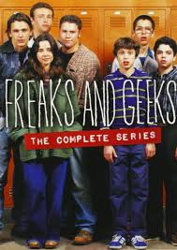

TV: Freaks and Geeks



Catch and Release: Bridget Jones’s Diary Trilogy

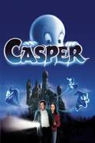

Rental: Casper



TV: Unbreakable Kimmy Schmidt



Rental: Midnight in Paris

TV: Scandal



Catch and Release: Gilmore Girls Revival

In Theaters: The Light Between Oceans

xsdfds fsdfzczxsfs



Rental: Lost in Translation

Ksdjfkldsjf;lksdjf;



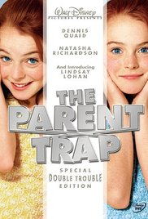

In Theaters: Sausage Party

Rental: The Parent Trap



Netflix: Friday Night Lights



TV: Orange is the New Black



Coming Soon: The Girl on the Train

Rental: Tootsie



